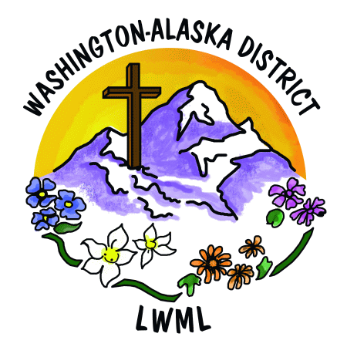
Lutheran Women’s Missionary League
Washington-Alaska District
www.wa-aklwml.org

